**Jenkins + buildpack** [How to Build a Container Image Using Buildpacks](https://youtu.be/d8C0yoZAn84)

**Jenkins + buildKit** [How to Build a Container Image Using BuildKit](https://youtu.be/9CRDMs5D3kM)

**Jenkins + Dagger**  [Using Dagger With Jenkins](https://youtu.be/MDbfRs54b-M)

**Setup Docker As Build for Jenkins** [How to Setup Docker Containers As Build Agents for Jenkins](https://youtu.be/ymI02j-hqpU)

Docker usecase

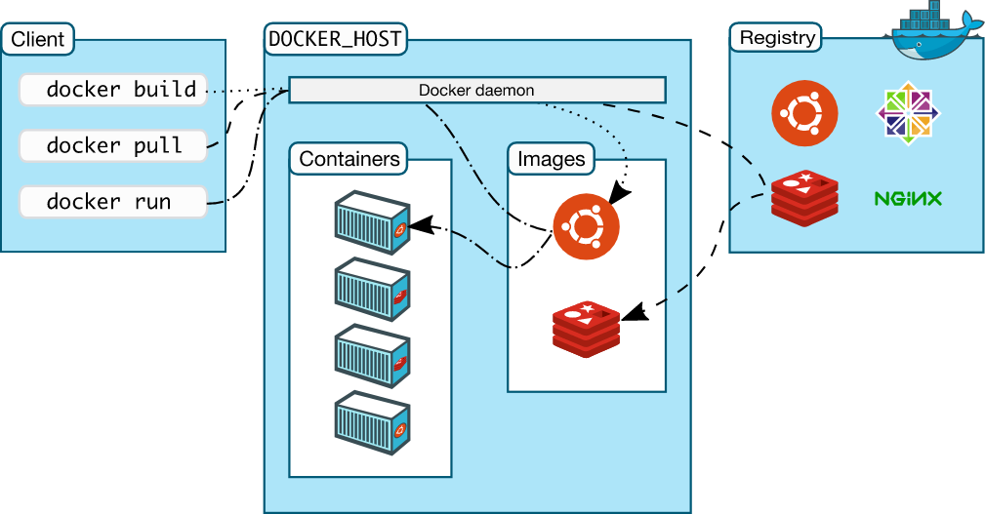

Reduce docker images size - <https://medium.com/nexton/how-to-optimize-docker-images-using-dive-dc590f45dbf5>

Dive tool —- <https://gochronicles.com/dive/>

Docker buildkit —- <https://docs.docker.com/build/buildkit/>

Docker buildx —- <https://github.com/docker/buildx>

Buildkit without docker —- <https://github.com/moby/buildkit>

**Before**

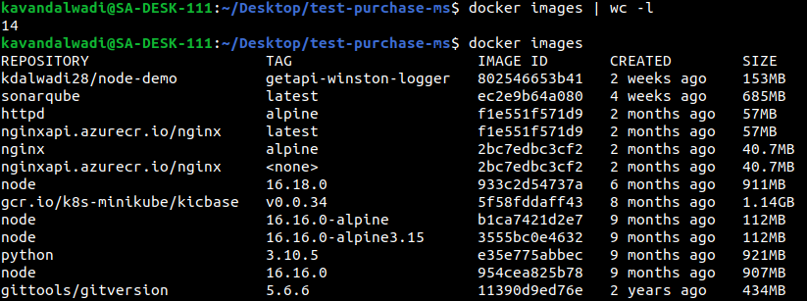

*Dockerfile-*

FROM node:14.15.0

RUN npm install pm2 -g

WORKDIR /app

COPY package*.json ./

RUN npm install

COPY . /app/

ENV NODE_OPTIONS=--max-old-space-size=7168

RUN npm run build-prod && cp ./firebase-prod/firebase-admin-sdk.json ./dist/config/

CMD [ "pm2-runtime", "/app/dist/index.js" ]

*Command- time docker build -t purchaseog -f DockerfileOg .*

real 3m34.372s

user 0m0.427s

sys 0m0.329s

**After**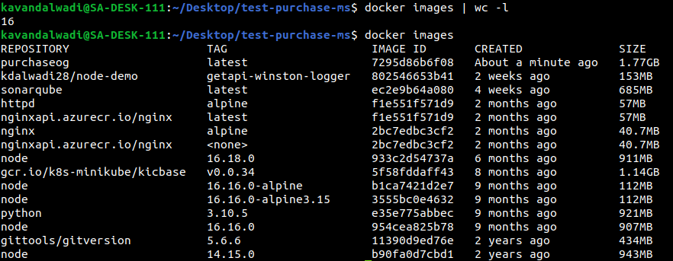

Docker image-

REPOSITORY TAG IMAGE ID CREATED SIZE

purchaseog latest 7295d86b6f08 3 minutes ago 1.77GB

**Using BuildKit**  
**Before**



*Dockerfile-*

FROM node:14.15.0 AS build

WORKDIR /app

COPY package*.json ./

RUN npm install

COPY . /app/

ENV NODE_OPTIONS=--max-old-space-size=7168

RUN npm run build-prod && cp ./firebase-prod/firebase-admin-sdk.json ./dist/config/

FROM node:14.15.5-alpine3.13 AS server

RUN npm install pm2 -g

WORKDIR /app

COPY --from=build /app/dist /app/

COPY --from=build /app/node_modules /app/node_modules/

CMD [ "pm2-runtime", "/app/dist/index.js" ]

*Command- time* ***DOCKER_BUILDKIT=1*** *docker build -t purchase-stage-kit -f Dockerfile-stage .*

real 2m34.803s

user 0m1.005s

sys 0m0.551s

**After**

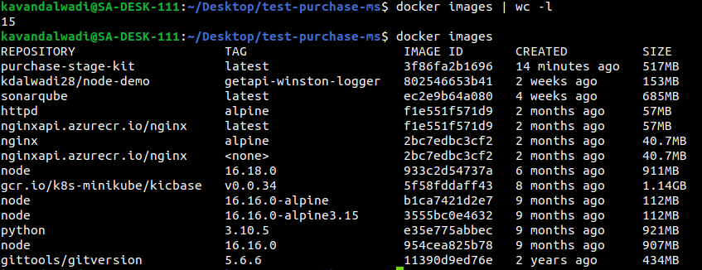

REPOSITORY TAG IMAGE ID CREATED SIZE

purchase-stage-kit latest 3f86fa2b1696 14 minutes ago 517MB